CO2 ASSESSMENT TOOL 1 – DESIGN AND CONNECTIVITY
DSA05 Query Processing for Data Science with Real Time Applications

Manisha M (192424130)

Scenario 2: Hospital Patient Record Management System
A multi-specialty hospital receives thousands of patients every month. Currently, patient records are maintained manually, making it difficult to track patient history, doctor consultations, prescriptions, laboratory tests, and billing information. The hospital management wants a database-driven application that can store patient details, doctor information, appointments, treatment records, and payment details. Each patient may visit multiple doctors over time, and doctors may consult many patients. Laboratory tests and prescriptions must also be linked to patient records. The system should provide quick access to patient histories and generate reports on disease trends and doctor workloads. Design a relational database schema for this system and use Python SQL libraries to connect to the database and manage patient information efficiently.

PROGRAM:
import sqlite3
conn = sqlite3.connect("hospital.db")
cursor = conn.cursor()
# Create Patient Table
cursor.execute("""
CREATE TABLE Patient(
patient_id INTEGER PRIMARY KEY,
name TEXT,
age INTEGER,
gender TEXT,
phone TEXT,
address TEXT
)
""")
# Create Doctor Table
cursor.execute("""
CREATE TABLE Doctor(
doctor_id INTEGER PRIMARY KEY,
name TEXT,
specialization TEXT,
phone TEXT
)
""")
# Create Appointment Table
cursor.execute("""
CREATE TABLE Appointment(
appointment_id INTEGER PRIMARY KEY,
patient_id INTEGER,
doctor_id INTEGER,
appointment_date TEXT,
FOREIGN KEY(patient_id) REFERENCES Patient(patient_id),
FOREIGN KEY(doctor_id) REFERENCES Doctor(doctor_id)
)
""")
# Create Prescription Table
cursor.execute("""
CREATE TABLE Prescription(
prescription_id INTEGER PRIMARY KEY,
patient_id INTEGER,
doctor_id INTEGER,
medicine TEXT,
dosage TEXT,
FOREIGN KEY(patient_id) REFERENCES Patient(patient_id),
FOREIGN KEY(doctor_id) REFERENCES Doctor(doctor_id)
)
"""
# Create Laboratory Table
cursor.execute("""
CREATE TABLE Laboratory(
test_id INTEGER PRIMARY KEY,
patient_id INTEGER,
test_name TEXT,
result TEXT,
FOREIGN KEY(patient_id) REFERENCES Patient(patient_id)
)
""")

# Create Billing Table
cursor.execute("""
CREATE TABLE Billing(
bill_id INTEGER PRIMARY KEY,
patient_id INTEGER,
amount REAL,
payment_status TEXT,
FOREIGN KEY(patient_id) REFERENCES Patient(patient_id)
)
""")
conn.commit()
# ---------------- CREATE ----------------
cursor.execute("""
INSERT INTO Patient
(patient_id, name, age, gender, phone, address)
VALUES
(1,'Ravi',25,'Male','9876543210','Chennai')
""")
cursor.execute("""
INSERT INTO Doctor
VALUES
(101,'Dr. Kumar','Cardiology','9876500000')
""")
cursor.execute("""
INSERT INTO Appointment
VALUES
(1,1,101,'2026-08-01')
"""
cursor.execute("""
INSERT INTO Prescription
VALUES
(1,1,101,'Paracetamol','1 Tablet')
""")
cursor.execute("""
INSERT INTO Laboratory
VALUES
(1,1,'Blood Test','Normal')
""")
cursor.execute("""
INSERT INTO Billing
VALUES
(1,1,1500,'Paid')
""")
conn.commit()
# ---------------- READ ----------------

print("Patient Records")
cursor.execute("SELECT * FROM Patient")
for row in cursor.fetchall():
print(row)
# ---------------- UPDATE ----------------
cursor.execute("""
UPDATE Patient
SET phone='9999999999'
WHERE patient_id=1
""")
conn.commit()
print("\nAfter Update")
cursor.execute("SELECT * FROM Patient")
for row in cursor.fetchall():
print(row)
# ---------------- JOIN ----------------
print("\nPatient Appointment Details")
cursor.execute("""
SELECT Patient.name,
Doctor.name,
Appointment.appointment_date
FROM Appointment
JOIN Patient
ON Appointment.patient_id=Patient.patient_id
JOIN Doctor
ON Appointment.doctor_id=Doctor.doctor_id
""")
for row in cursor.fetchall():
print("Patient:", row[0])
print("Doctor :", row[1])
print("Date :", row[2])
print()
# ---------------- DELETE ----------------
cursor.execute("""
DELETE FROM Patient
WHERE patient_id=1
""")
conn.commit()
print("After Delete")
cursor.execute("SELECT * FROM Patient")
print(cursor.fetchall())
conn.close()
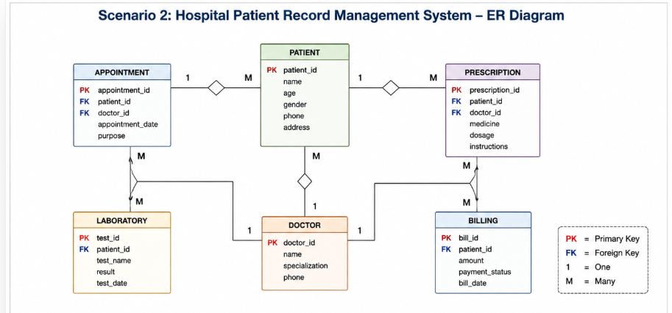
OUTPUT:
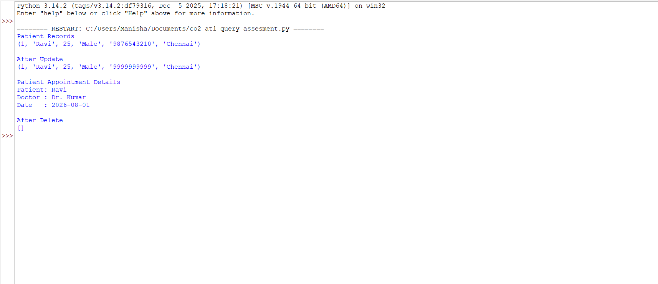

Scenario 10: Smart Transportation and Ticket Booking System
A transportation company operates buses across multiple cities. Passengers can search routes, book tickets, cancel reservations, and make online payments. The company must maintain information about buses, routes, schedules, drivers, passengers, and ticket bookings. Each bus operates on multiple routes, and passengers may make several bookings over time. Management wants to analyze passenger demand, route utilization, and revenue generation. Design a database system that efficiently stores transportation data and supports ticket booking operations. Use Python SQL libraries to connect to the database and perform CRUD operations for route management, passenger registration, and ticket reservations.
PROGRAM:
CREATE DATABASE TransportDB;
USE TransportDB;
Create Tables
CREATE TABLE Route(
route_id INT PRIMARY KEY,
source VARCHAR(50),
destination VARCHAR(50),
distance INT
);

CREATE TABLE Bus(
bus_id INT PRIMARY KEY,
bus_name VARCHAR(50),
driver_name VARCHAR(50),
capacity INT,
route_id INT,
FOREIGN KEY(route_id) REFERENCES Route(route_id)
);
CREATE TABLE Passenger(
passenger_id INT PRIMARY KEY,
name VARCHAR(50),
age INT,
gender VARCHAR(10),
phone VARCHAR(15)
);
CREATE TABLE Ticket(
ticket_id INT PRIMARY KEY,
passenger_id INT,
bus_id INT,
journey_date DATE,
seat_no VARCHAR(10),
fare DECIMAL(10,2),
FOREIGN KEY(passenger_id) REFERENCES Passenger(passenger_id),
FOREIGN KEY(bus_id) REFERENCES Bus(bus_id)
);
import mysql.connector
# Connect to MySQL
conn = mysql.connector.connect(
host="localhost",
user="root",
password="your_password",
database="TransportDB"
)
cursor = conn.cursor()
# ---------------- CREATE ----------------
cursor.execute("""
INSERT INTO Route
VALUES(1,'Chennai','Coimbatore',500)
""")
cursor.execute("""
INSERT INTO Bus
VALUES(101,'Express Bus','Ramesh',50,1)
""")
cursor.execute("""
INSERT INTO Passenger
VALUES(201,'Manisha',20,'Female','9876543210')
"""
cursor.execute("""
INSERT INTO Ticket
VALUES(301,201,101,'2026-08-05','A1',750.00)
""")
conn.commit(
print("Data Inserted Successfully")
# ---------------- READ ----------------
print("\nPassenger Details")
cursor.execute("SELECT * FROM Passenger")
for row in cursor.fetchall():
print(row)
# ---------------- UPDATE ----------------
cursor.execute("""
UPDATE Passenger
SET phone='9999999999'
WHERE passenger_id=201
""")
conn.commit()
print("\nAfter Update")
cursor.execute("SELECT * FROM Passenger")
for row in cursor.fetchall():
print(row)
# ---------------- JOIN ----------------

print("\nTicket Booking Details"
cursor.execute("""
SELECT
Passenger.name,
Bus.bus_name,
Route.source,
Route.destination,
Ticket.journey_date,
Ticket.seat_no,
Ticket.fare
FROM Ticket
JOIN Passenger
ON Ticket.passenger_id=Passenger.passenger_id
JOIN Bus
ON Ticket.bus_id=Bus.bus_id
JOIN Route
ON Bus.route_id=Route.route_id
""")
for row in cursor.fetchall():
print("Passenger :", row[0])
print("Bus :", row[1])
print("Route :", row[2], "to", row[3])
print("Date :", row[4])
print("Seat :", row[5])
print("Fare :", row[6])
print()
# ---------------- DELETE ----------------
cursor.execute("""
DELETE FROM Ticket
WHERE passenger_id=201
""")
cursor.execute("""
conn.commit()
print("Passenger Deleted Successfully")
print("\nRemaining Passengers")
cursor.execute("SELECT * FROM Passenger")
for row in cursor.fetchall():
print(row)
cursor.close()
conn.close()
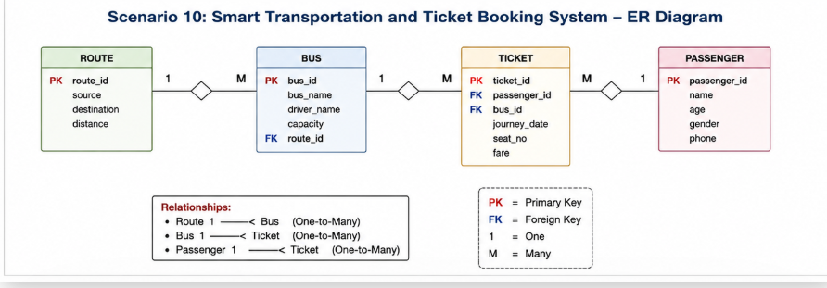
OUTPUT:
